Exercise

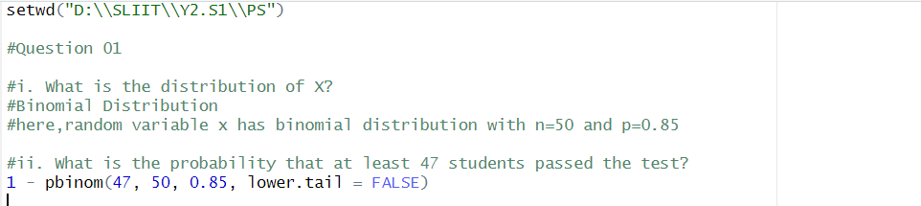Question 01



Question 02

